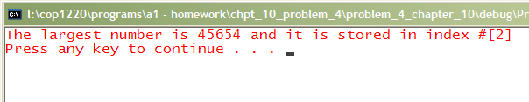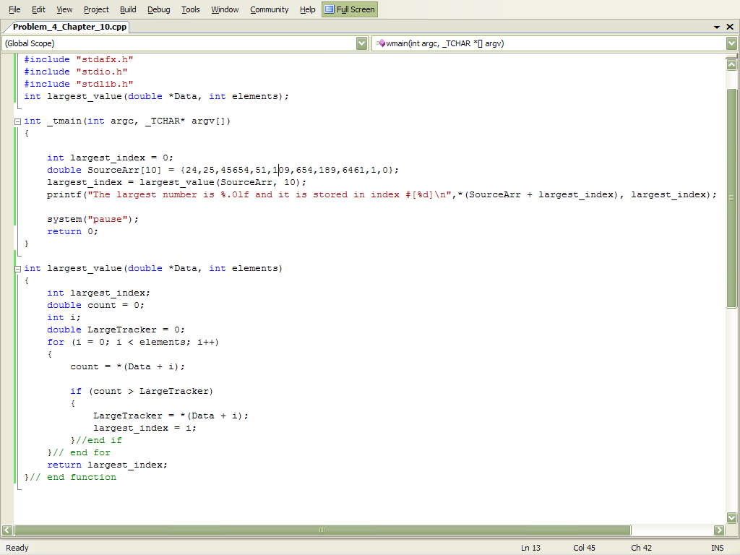
Question I tried to make [ i ] a double value because the array is a double and it said to make it an integer value whats the deal with that? Dose that only apply to MultiDimension Arrays? Double is 8 bits per address and int is 4 bits per address ?

